DSA LAB 2 HOME TASKS
NAME: MUHAMMAD ANAS| ID: 25K-0577 | SECTION: BCS-3A

TASK 3:
CODE:
#include <iostream>
using namespace std;

int main(){
int n;
cout << "Enter the size of an array: ";
cin >> n;

int *arr = new int[n];
int sum = 0;

for(int i=0; i<n; i++){
cout << "Enter value " << i+1 << ": ";
cin >> arr[i];
sum += arr[i];
}

cout << "\nArray Elements\n";
for(int i=0; i<n; i++){
cout << "index " << i << ": " << arr[i] << endl;
}
cout << "Sum: " << sum << endl << endl;

delete[] arr;
}

OUTPUT:
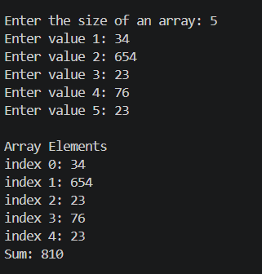
TASK 4:
CODE:
#include <iostream>
using namespace std;

int main(){
int r, c;
cout << "Enter the number of rows and columns: ";
cin >> r >> c;

int **arr = new int*[r];

for(int i=0; i<r; i++){
arr[i] = new int[c];
}

int sum = 0;

cout << "\nEnter values\n";
for(int i=0; i<r; i++){
cout << "Row " << i+1 << ": " << endl;
for(int j=0; j<c; j++){
cout << "Value " << j+1 << ": ";
cin >> arr[i][j];
sum += arr[i][j];
}
}

cout << "\nMatrix\n";
for(int i=0; i<r; i++){
for(int j=0; j<c; j++){
cout << arr[i][j] << " ";
}
cout << endl;
}

cout << "\nSum: " << sum << endl << endl;

for(int i=0; i<r; i++){
delete[] arr[i];
}
delete[] arr;
}

OUTPUT:
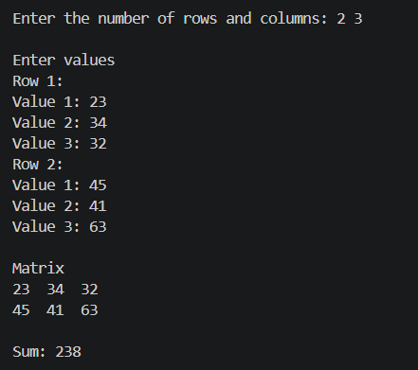
TASK 6:
CODE:
#include <iostream>
using namespace std;

int isValid(int size, int idx){
if(idx < 0 || idx >=size) return false;
return true;
}

void access(int arr[], int size, int idx){
if(isValid(size, idx)){
cout << "Element at index " << idx << ": " << arr[idx] << endl << endl;
}
else{
cout << "Index out of bound!"<< endl << endl;
}
}

void modify(int arr[], int size, int idx, int update){
if(isValid(size, idx)){
arr[idx] = update;
cout << "Updated Array: ";
for(int i=0; i<size; i++){
cout << arr[i] << " ";
}
}
else{
cout << "Index out of bound!"<< endl << endl;
}
}

int main(){
int n;
cout << "Enter size of an array: ";
cin >> n;

int *arr = new int[n];

for(int i=0; i<n; i++){
cout << "Enter Value " << i+1 << ": ";
cin >> arr[i];
}

int choice, idx;
cout << "\nChoose from the options\n";
do{
cout << "1. Access \n2. Modify \n3. Exit" << endl;
cout << "Enter your choice: ";
cin >> choice;

switch(choice){
case 1:
cout << "Enter index: ";
cin >> idx;
access(arr, n, idx);
break;
case 2:
int val;
cout << "Enter index: ";
cin >> idx;
cout << "Enter new value: ";
cin >> val;
modify(arr, n, idx, val);
break;
case 3:
cout << "Exiting!!!\n\n";
break;
}
}while(choice != 3);
}

OUTPUT:
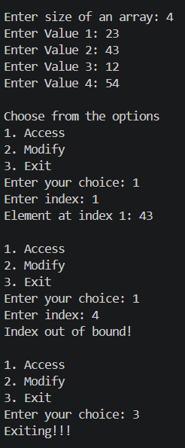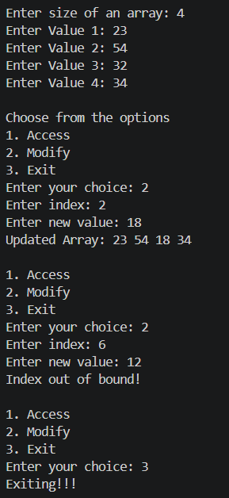

TASK 7:
CODE:
#include <iostream>
using namespace std;

int main() {
int startIdx = 0;
int size = 0;

cout << "Enter custom starting index: ";
cin >> startIdx;

cout << "Enter array size: ";
cin >> size;

if (size <= 0) {
cout << "Invalid array size!" << endl;
return 1;
}

int endIdx = startIdx + size - 1;

int* arr = new int[size];

cout << "\nValid index range: [" << startIdx << " to " << endIdx << "]" << endl;

cout << "\nInput Elements" << endl;
for (int idx = startIdx; idx <= endIdx; ++idx) {
int internalIdx = idx - startIdx;
cout << "Enter value for index [" << idx << "]: ";
cin >> arr[internalIdx];
}

cout << "\nArray Elements" << endl;
for (int idx = startIdx; idx <= endIdx; ++idx) {
int internalIdx = idx - startIdx;
cout << "Index [" << idx << "] = " << arr[internalIdx] << endl;
}

cout << "\nSafe Index Access Check" << endl;
int userIdx = 0;
cout << "Enter custom index to access: ";
cin >> userIdx;

if (userIdx >= startIdx && userIdx <= endIdx) {
int internalIdx = userIdx - startIdx;
cout << "Value at index [" << userIdx << "] is: " << arr[internalIdx] << endl;
} else {
cout << "Error: Index " << userIdx << " is OUT OF BOUNDS! Valid range is ["
<< startIdx << " to " << endIdx << "]." << endl;
}

cout << "\nSafe Index Modification Check" << endl;
cout << "Enter custom index to modify: ";
cin >> userIdx;

if (userIdx >= startIdx && userIdx <= endIdx) {
int internalIdx = userIdx - startIdx;
int newVal;
cout << "Enter new value: ";
cin >> newVal;
arr[internalIdx] = newVal;
cout << "Successfully updated index [" << userIdx << "] to " << newVal << endl;
} else {
cout << "Error: Index " << userIdx << " is OUT OF BOUNDS! Valid range is ["
<< startIdx << " to " << endIdx << "]." << endl;
}

cout << "\nFinal Array State" << endl;
for (int idx = startIdx; idx <= endIdx; ++idx) {
int internalIdx = idx - startIdx;
cout << "Index [" << idx << "] = " << arr[internalIdx] << endl;
}

delete[] arr;

return 0;
}

OUTPUT:
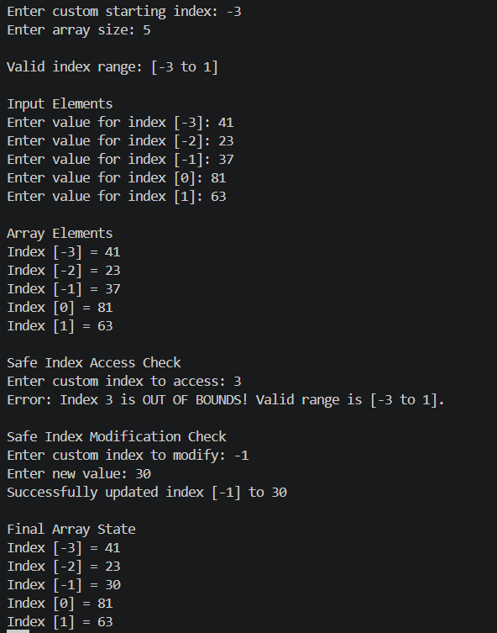

TASK 8:
CODE:
#include <iostream>
using namespace std;

int main(){
int r;
cout << "Enter number of rows: ";
cin >> r;

int **arr = new int*[r];

int col[r];

for(int i=0; i<r; i++){
cout << "Enter col of row " << i+1 << ": ";
cin >> col[i];

arr[i] = new int[col[i]];
}

for(int i=0; i<r; i++){
cout << "Enter Row " << i+1 << " values\n";
for(int j=0; j<col[i]; j++){
cout << "Enter Value " << j+1 << ": ";
cin >> arr[i][j];
}
}

cout << "\nMATRIX\n";
for(int i=0; i<r; i++){
for(int j=0; j<col[i]; j++){
cout << arr[i][j] << " ";
}
cout << endl;
}

int max = 0;
for(int i=0; i<r; i++){
for(int j=0; j<col[i]; j++){
if(arr[i][j] > max) max = arr[i][j];
}
cout << "Row " << i+1 << " maximum value: " << max << endl;
}

for(int i=0; i<r; i++){
delete[] arr[i];
}

delete[] arr;
}

OUTPUT:
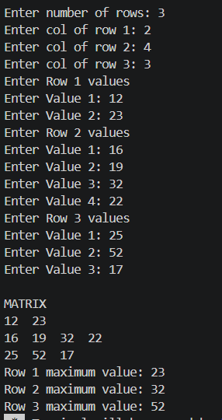

TASK 10:
CODE:
#include <iostream>
using namespace std;

int* resize1DArray(int* oldArr, int oldSize, int newSize) {
int* newArr = new int[newSize];
int minSize = (oldSize < newSize) ? oldSize : newSize;

for (int i = 0; i < minSize; ++i) {
newArr[i] = oldArr[i];
}

delete[] oldArr;
return newArr;
}

int main() {
cout << "=== Part 1: Resizable 1D Dynamic Array ===" << endl;

int size1D;
cout << "Enter initial size for 1D array: ";
cin >> size1D;

int* arr1D = new int[size1D];

cout << "Enter " << size1D << " integer values: ";
for (int i = 0; i < size1D; ++i) {
cin >> arr1D[i];
}

cout << "\nCurrent 1D Array elements: ";
for (int i = 0; i < size1D; ++i) {
cout << arr1D[i] << " ";
}
cout << endl;

int readIndex;
cout << "\nEnter index to access safely: ";
cin >> readIndex;

if (readIndex >= 0 && readIndex < size1D) {
cout << "Value at index " << readIndex << ": " << arr1D[readIndex] << endl;
} else {
cout << "Error: Index " << readIndex << " is out of bounds!" << endl;
}

int writeIndex, newVal;
cout << "Enter index to modify safely: ";
cin >> writeIndex;

cout << "Enter new value: ";
cin >> newVal;

if (writeIndex >= 0 && writeIndex < size1D) {
arr1D[writeIndex] = newVal;
cout << "Successfully updated index " << writeIndex << endl;
} else {
cout << "Error: Index " << writeIndex << " is out of bounds! Operation canceled." << endl;
}

int newSize1D;
cout << "\nEnter new size to resize 1D array: ";
cin >> newSize1D;

arr1D = resize1DArray(arr1D, size1D, newSize1D);
size1D = newSize1D;

cout << "Resized 1D Array elements (preserved data): ";
for (int i = 0; i < size1D; ++i) {
cout << arr1D[i] << " ";
}
cout << "\n\n";

cout << "=== Part 2: 2D Dynamic Jagged Array ===" << endl;

int rows;
cout << "Enter number of rows for jagged array: ";
cin >> rows;

int** jagged = new int*[rows];
int* rowSizes = new int[rows];

for (int i = 0; i < rows; ++i) {
cout << "Enter number of columns for Row " << i << ": ";
cin >> rowSizes[i];
jagged[i] = new int[rowSizes[i]];
}

cout << "\n--- Input Values for Jagged Array ---" << endl;
for (int i = 0; i < rows; ++i) {
cout << "Row " << i << " (" << rowSizes[i] << " elements): ";
for (int j = 0; j < rowSizes[i]; ++j) {
cin >> jagged[i][j];
}
}

cout << "\n--- Jagged Array Elements & Row Maximums ---" << endl;
for (int i = 0; i < rows; ++i) {
cout << "Row " << i << ": ";
int rowMax = 0;

for (int j = 0; j < rowSizes[i]; ++j) {
cout << jagged[i][j] << " ";
if (jagged[i][j] > rowMax) {
rowMax = jagged[i][j];
}
}
cout << " | Max: " << rowMax << endl;
}

delete[] arr1D;
arr1D = nullptr;

for (int i = 0; i < rows; ++i) {
delete[] jagged[i];
}
delete[] jagged;
delete[] rowSizes;

cout << "\nMemory successfully released." << endl;

return 0;
}

OUTPUT:
